**Service tools in ICM**

To access services tools we need to login to AW (See how to login to AW in the AW SOP) . There we find the folder Unified CCE Administration tools. Click on the folder to see the below page.

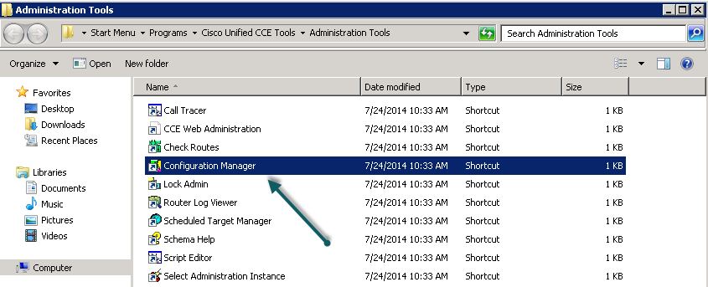

Click on the Configuration manager to redirect to the Configuration Manager page.

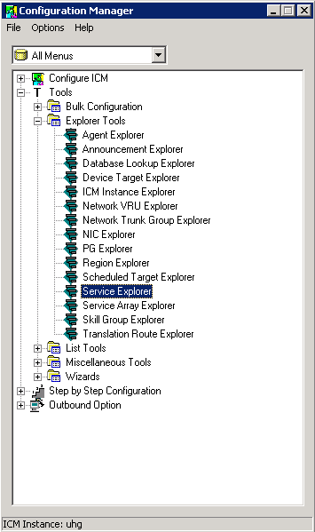

Click on the  button on tools then the  at explorer tools, there we find the Service explorer.

Click on the service explorer tab to open the below page.

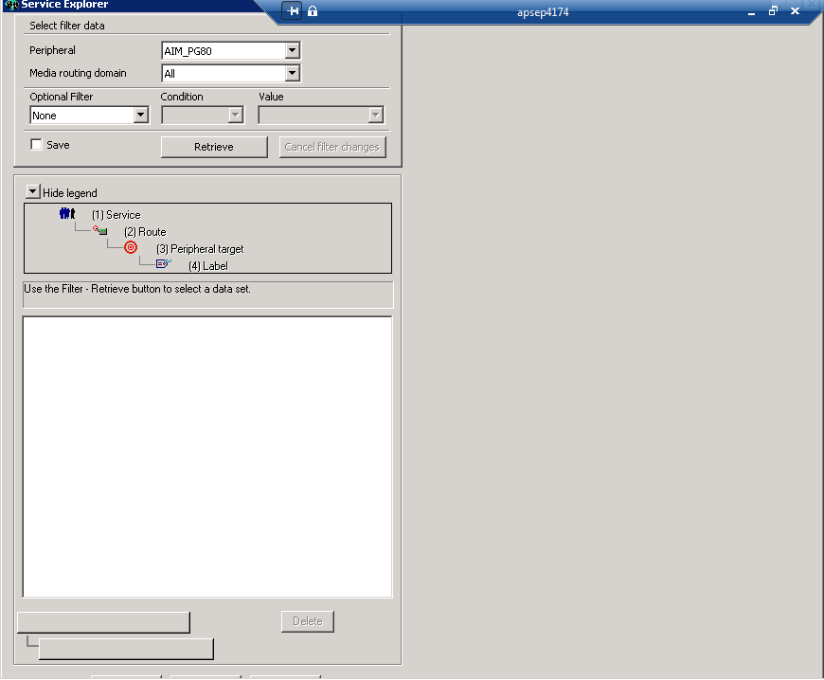

Now select the Peripheral gateway in which you want to add your service from the drop down.

(Please check the PDF document on Peripheral gateways to select the appropriate peripheral)

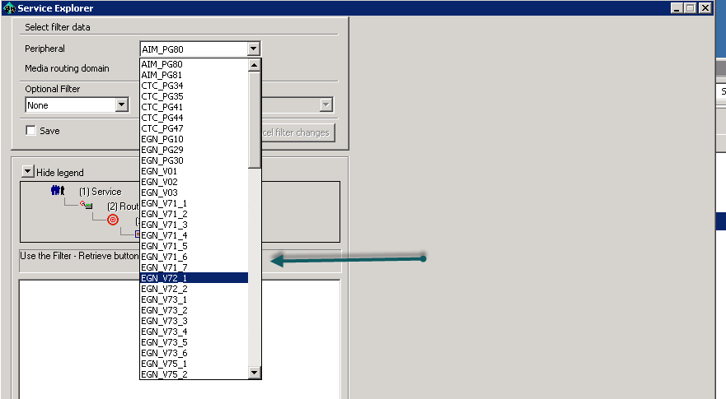

Now click the **retrieve** button to view all the services.

In order to create a new service we click the retrieve button and see the **add services** button which is located below.

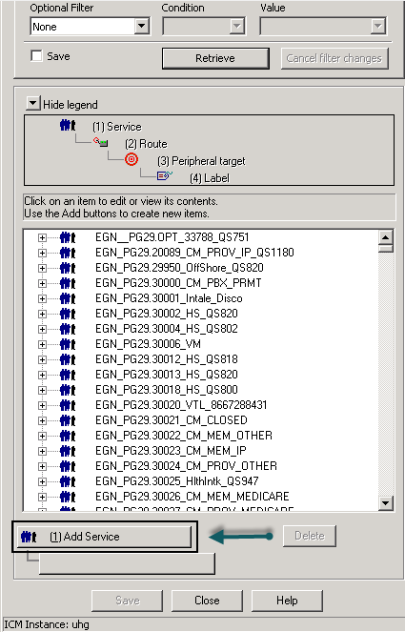

We get the first set of attributes to be filled once we click on the add service with three tabs that needs to be filled.

